Are you wondering what the next few days holds in store for you, but do not always have your Google calendar open? There is a way to enable a “Calendar Gadget” that will appear on your Inbox when viewing your email using a web browser. Once set, it will appear each time your log in to your Marvelwood email.
Here is how you go about activating the calendar gadget:
- Open your web browser and navigate to google.com and sign into your account. Once signed in, go to your email.
- In the upper right corner of the page, click the Settings (gear) icon and select Settings
- Click the Labs option at the top of the page
- Scroll down to locate the Google Calendar gadget and Enable it
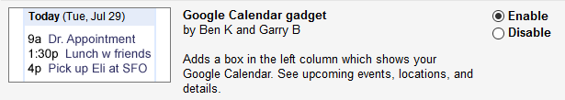
- Once enabled, scroll down to the bottom of the page and click Save Changes
- Back in your Inbox, click the 3 ellipse icon on the lower left section of the page | 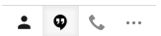
- The Google Calendar Gadget appears and displays a (very) short description of the events in your Google calendar. You can click on the event to get a bit more information. You can also click on the minus sign in the upper right corner of the gadget to minimize it. | 