The following steps outline how to set your Out Of Office notification in Google
- Log into you Marvelwood Google account.
- Click the drop down arrow next to the Settings icon and select Settings.
- Select the General tab near the top of the page if it not already selected. | 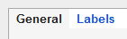
- Scroll down to the Vacation responder section. | 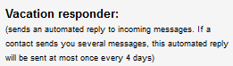
- Turn on the notification, set the start and end dates and your personalized message as shown below.
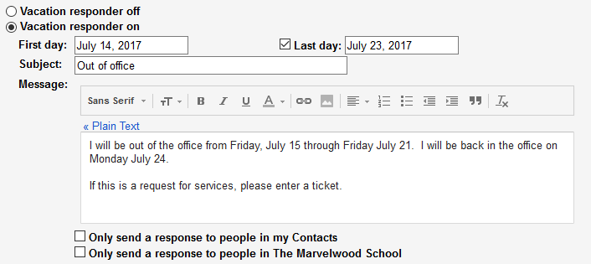
- Click the Save Changes button.

